**DESIGN OF DIGITAL SYSTEMS PROJECT**

**16 WAY CLAP SWITCH**

**BY**

**SANDEEP N MENON**

**14CO140**

**VINEETH REDDY**

**14CO151**

**OBJECTIVE AND SCOPE OF THE PROJECT**

Imagine turning off and on the electronic devices in your home with just the sound of your clap. Clap switch is a switch which can switch on/off any electrical circuit by the sound of the clap.

This project aims at simulating a circuit that helps us to manage the appliances in our homes without actually having to go to the switch. All you need is to just clap in front of the microphone and after that, the device attached to the microphone becomes “ON” or “OFF”.

**SCOPE**

1. A clap switch is generally used for a light, television, radio or similar electronic device that the person will want to on/off from the bed.

2. The primary application involves an elderly or mobility impaired person.

3.Easy remote control access of many appliances without having to go near it.

4. The circuit designed in this project can be easily modified to accept other types of inputs (other than clap), for example Wifi or bluetooth signals.

5. The clap sequences can be made more friendly, as in one clap can switch on many appliances or something similar.

**INTRODUCTION**

The 16-way clap switch which can be used to efficiently switching ‘ON’ and ‘OFF’ 4 different devices simultaneously, without one’s output affecting the other. The basic idea this is that when you give a particular definite amount of time and if you clap your hands once in that particular time, device 1 is toggled, if you clap twice then device 2 is toggled, clapping thrice will make device 3 toggle and device 4 will be toggled when you clap four times. The circuit is designed such that, even if you don't clap or clap more than 4 times the circuit is not changed, hence the user should be aware of the time interval given specifically to give the set of claps.

The basic idea of how it works is that, the signal generator creates a clock pulse of the required frequency which in turn is given to a push down button which in this circuit acts as the clap generator based on the number of pushes. The decade counter then counts till it reaches the number of pushes to the button. The outputs from the decade counter will then be connected to flip flops so as to only take the final output from the decade counter as the input to the designed Moore machine. Moore machine is specifically used here because the output is not dependant on the inputs. Here the machine also depicts the change in the state on receiving the particular input. In this machine all the states have 8 transitions to them. Hence the state which it goes after receiving the input depicts the scenario after toggling the required device, hence the output of the Moore machine depicts the output of the final circuit.

Here the circuit is able to distinguish between a single clap or multiple claps or if there are no claps, and then decide by itself whether to toggle or not the particular device. Here the important thing to notice is that when the clap switch is used to toggle a particular device, the other devices are not affected, which is one of the important criteria taken care in case if it used in commercial purposes. To sum it up it is a switch which can be used to may or may not toggle a desired device.

**List of components used**

1. IC 74LS90 - Decade counter
2. IC 74LS74 - Dual D Flip-flop
3. IC 74LS86 - QUAD 2-IN EXOR
4. IC 74LS11 - 3 input AND gate
5. IC 4075 - 3 input OR gate
6. IC 74LS04 - HEX Inverter
7. Probes to depict appliances.
8. Signal Generator
9. Digital clock

**1. IC 74LS90 - Decade counter**

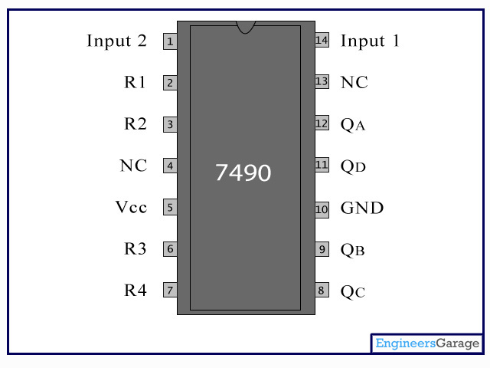

The 74LS90 integrated circuit is basically a MOD-10 decade counter that produces a BCD output code. The 74LS90 consists of four master-slave JK flip-flops internally connected to provide a MOD-2 (count-to-2) counter and a MOD-5 (count-to-5) counter. The 74LS90 has one independent toggle JK flip-flop driven by the CLK A input and three toggle JK flip-flops that form an asynchronous counter driven by the CLK B input as shown.

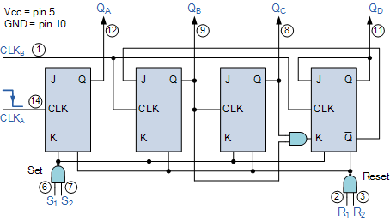

A BCD counter is a special type of a digital counter which can count to ten on the application of a clock signal.IC 74LS90 can be thought of as a mod 2 counter and mod 5 counter. Pin 14 is for mod 2 and pin 1 is for mod 5. R1 and R2 are the resets and R3 and R4 are the presets. QA, QB, QC and QD are the output lines.

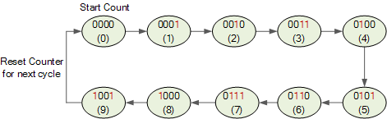

In the project design, the IC is used to count the number of claps given by the user in a specific time interval. It can be 1,2,3 or 4. All the other cases don't affect the Moore machine. Also the counter is reset after every set of claps, ie, D flip-flop resets the counter after a particular time interval if any input is given. An OR circuit of the last three bits of the counter is given as input to the D flip-flop and the output if the flip-flop is given as reset to the counter.

**2. IC - 74LS74 DUAL D-FLIP FLOP**

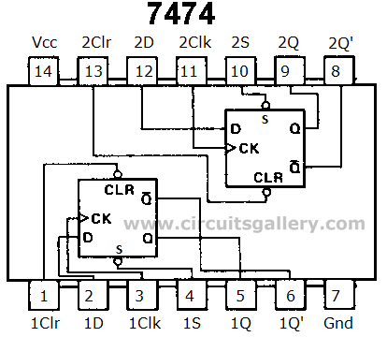

The D-flip-flop is also known as "data" or "delay" flip-flop. The D flip-flop captures the value of the D input at a definite portion of the clock cycle such as the rising edge of the clock. That captured value becomes the Q output. The D flip-flop can be viewed as a memory cell, a zero order hold or a delay line.

These flip-flops are very useful as they form the basis for shift registers which are essential part of many electronic devices. It can also be used as a frequency as a frequency divider in analogue circuits.

In the project design, these are used to implement the Moore machine derived for the demonstration of the clap switch circuit. The implementation involves transition from one state to other states on receiving certain inputs. In this case the inputs are the signals depicting the clap signals.

Also it is used to get the output from the decade counter in such a way that , only the last stable state of the decade counter in a time interval is given to the Moore machine

**3. IC 74LS86- QUAD 2-IN EXOR**

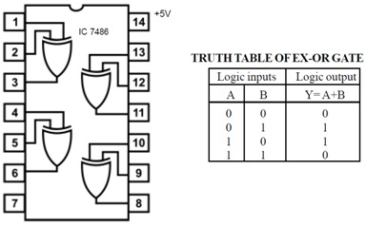

The 7486 IC package contains four independent positive logic XOR GATES. Pins 14 and 7 provide power for all four logic gates.

**XOR GATE** Logic-Rules:  
The output is HIGH when one OR the other input is HIGH, but NOT both. If both inputs are high output will be LOW.

The IC is used to implement the Boolean logic derived from the Karnaugh Map consisting of the input signals and the D flip-flop outputs. Its output is given back as input to the D flip-flop.

**4. IC 74LS11 3-INPUT AND GATE**

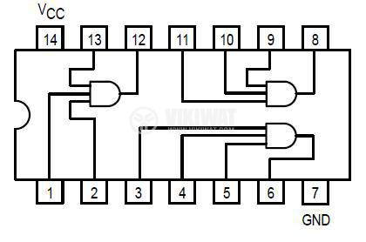

The IC is used to implement the Boolean logic derived from the Karnaugh Map consisting of the input signals and the D flip-flop outputs. Its output is given to the IC-7486 (XOR gate) along with one of the corresponding D output.

**5. Signal Generator**

A [**signal generator**](https://en.wikipedia.org/wiki/Function_generator) is a device which produces simple repetitive [waveforms](https://en.wikipedia.org/wiki/Waveform). Such devices contain an [electronic oscillator](https://en.wikipedia.org/wiki/Electronic_oscillator), a[circuit](https://en.wikipedia.org/wiki/Electronic_circuit) that is capable of creating a repetitive [waveform](https://en.wikipedia.org/wiki/Waveform). (Modern devices may use [digital signal processing](https://en.wikipedia.org/wiki/Digital_signal_processing) to synthesize waveforms, followed by a [digital to analog converter](https://en.wikipedia.org/wiki/Digital_to_analog_converter), or DAC, to produce an analog output). The most common waveform is a[sine wave](https://en.wikipedia.org/wiki/Sine_wave), but [sawtooth](https://en.wikipedia.org/wiki/Sawtooth_wave" \o "Sawtooth wave), step ([pulse](https://en.wikipedia.org/wiki/Pulse_(signal_processing))), [square](https://en.wikipedia.org/wiki/Square_wave), and [triangular](https://en.wikipedia.org/wiki/Triangle_wave) waveform oscillators are commonly available as are [arbitrary waveform generators](https://en.wikipedia.org/wiki/Arbitrary_waveform_generator) (AWGs).

Here in this project this device is used to simulate claps. The device is connected to a push button switch, so that every push allows in one wave from ( showing one clap). This is received by the decade counter and is counted.

The signal generator in multisim allows us to specify the type of wave, frequency, amplitude and many other characters of a wave.

**6. Digital Clock**

The digital clock is a type of digital power source, providing square wave signals in the required frequency.

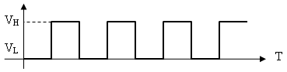

The decade counter and D flip-flops in the project design take clock inputs. The frequency may differ according the need.

**Logic Circuit**

Full circuit : -

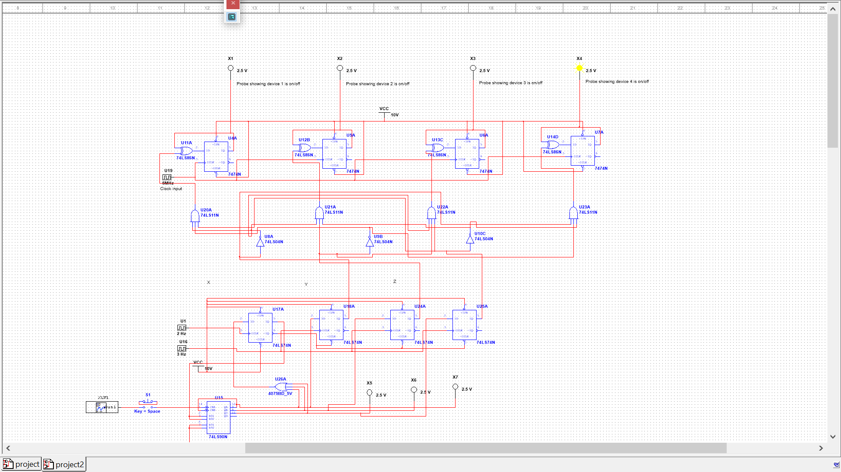

Moore Machine : -

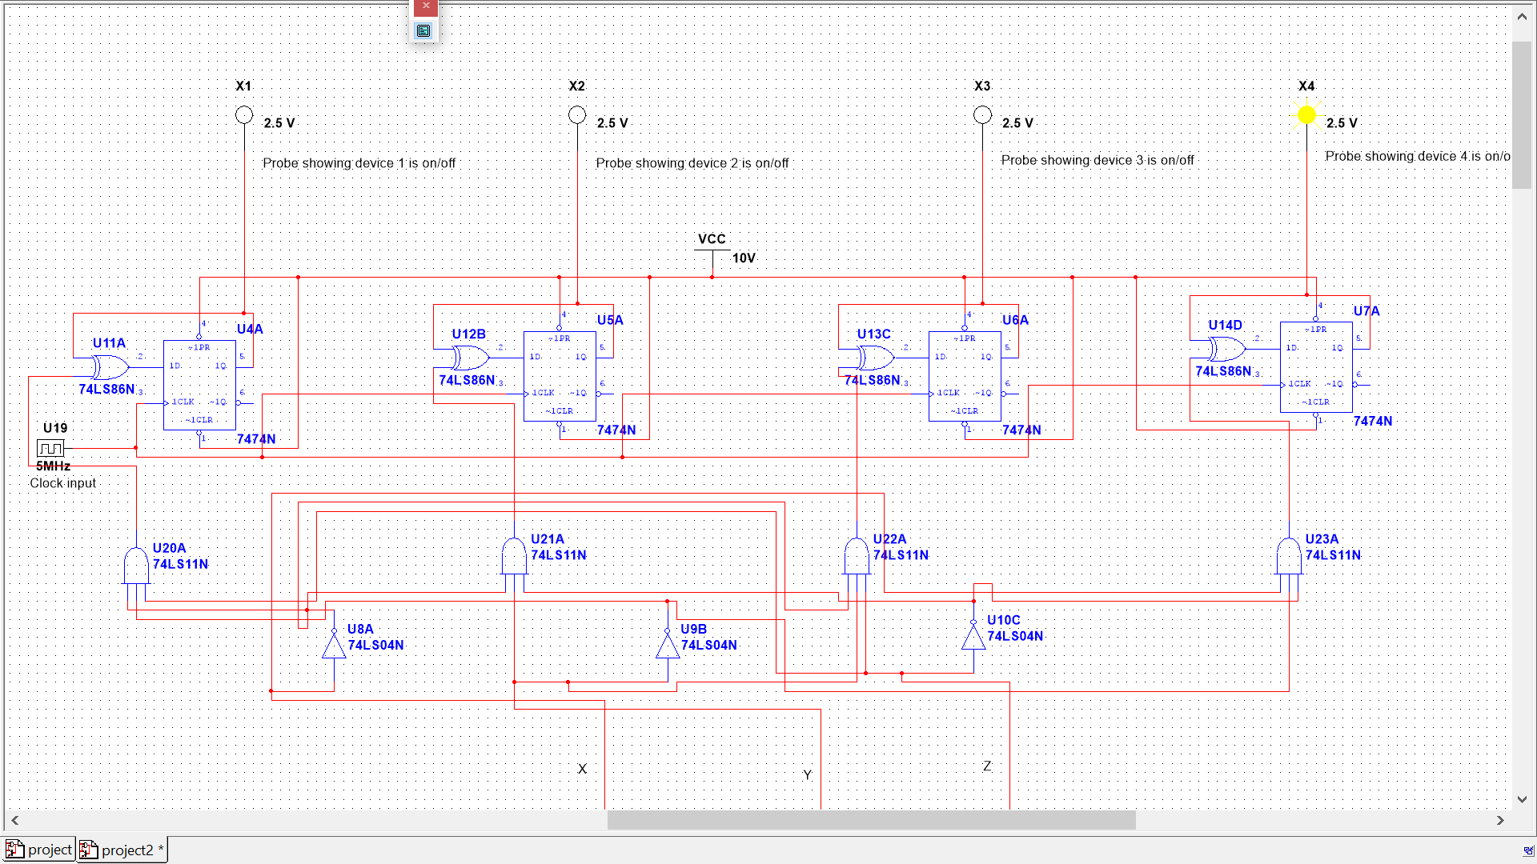

Clap simulation circuit : -

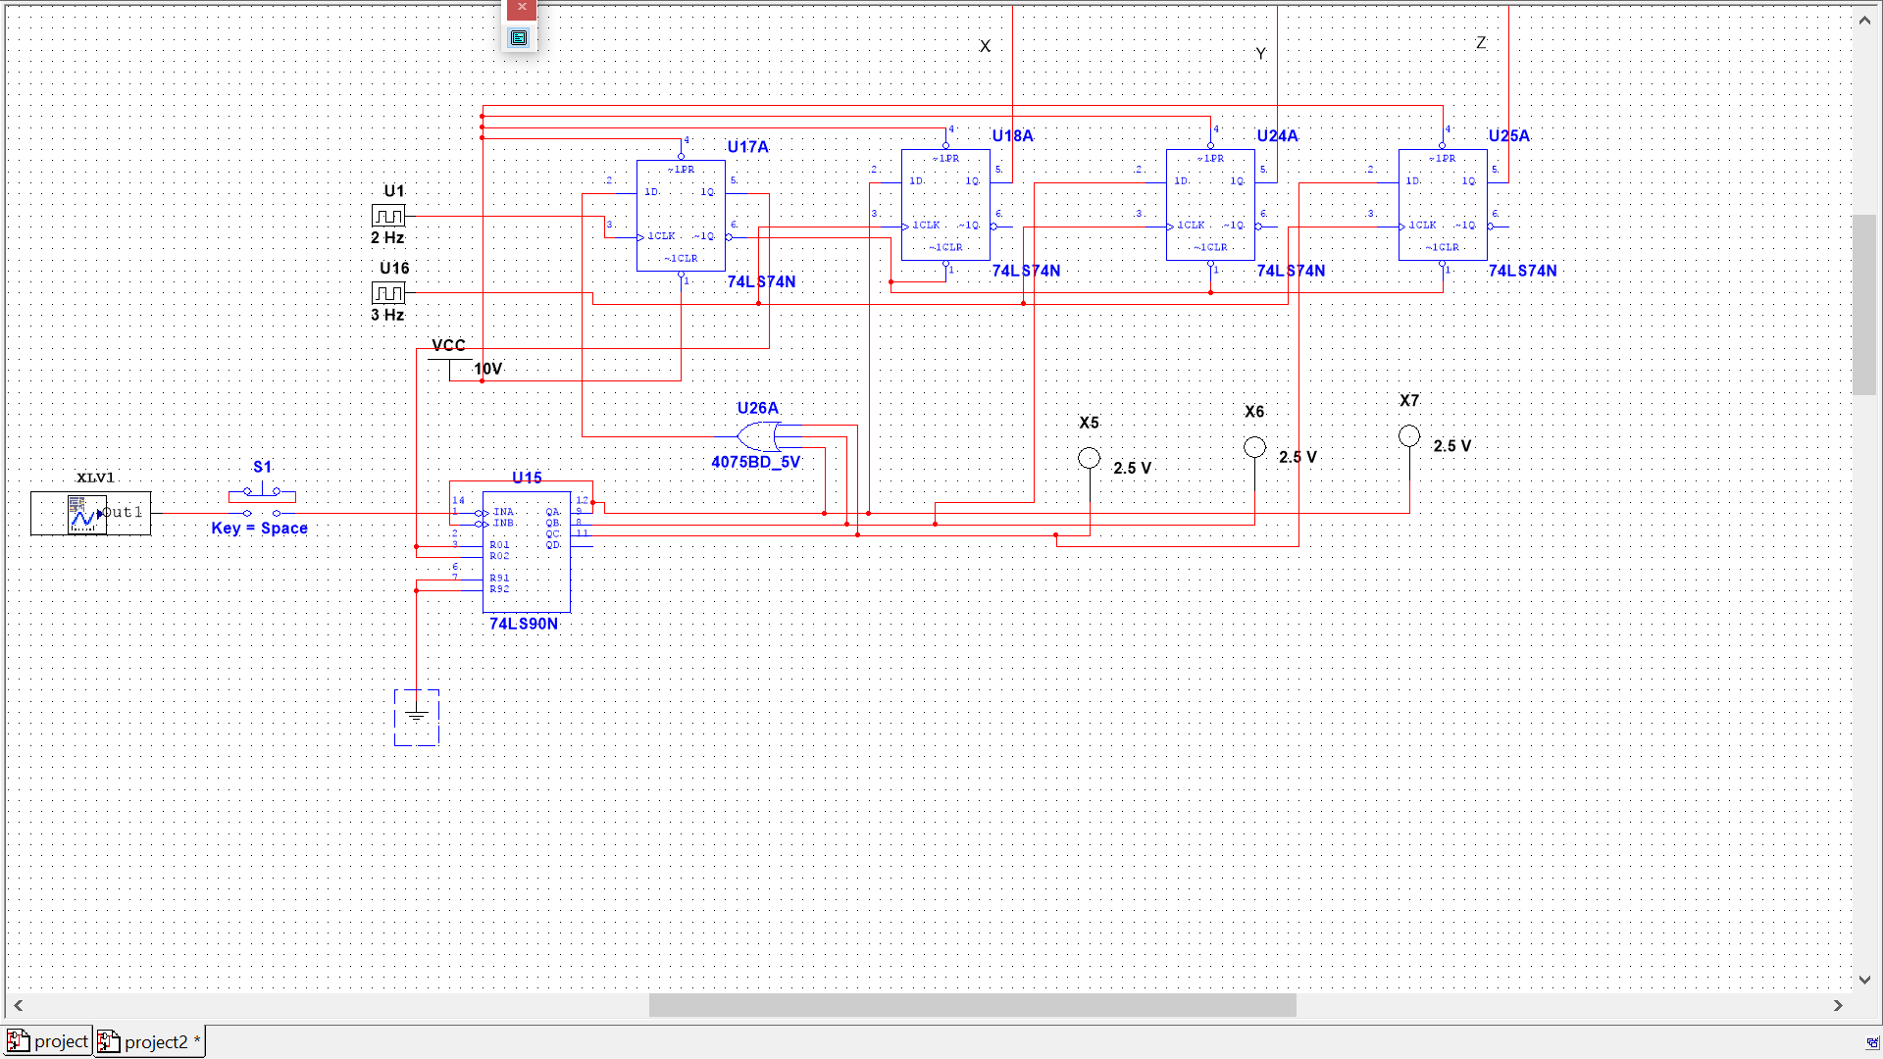

**Implementation and methodology adopted**

The circuit is divided into two main segments:

1. The clap simulation circuit

2. Moore machine

The clap simulation circuit consists of a signal generator to simulate the claps, a decade counter (IC 7490) to count the claps, D flip-flops to specifically take the final output from the decade counter after a specific time span. One D flip-flop is used to reset all the other D flip flops and the decade counter after an amount of time, as the counting of claps should be done from zero for each input.

Suppose the user inputs two claps, appliance number 2 turns on, then the counter and flip flops are reset to zero so that the next set of claps count from zero. If the frequency of the flip-flops is given as 3Hz, so every 0.33 seconds the flip flops send the state of the output lines of the decade counter to the Moore machine.

The Moore machine circuit is the central part of the project. The circuit depicts 4 appliances, all of the controlled by the sequence of claps 1,2,3,4 ie, (001,010,011,100). Let these bits be A,B and C respectively. Let the appliances be D,E,F and G. So the truth table of them will contain 28=128 states.

When ABC=001, appliance D toggles, ABC=010, E toggles, ABC=011, F toggles and when ABC=100, G toggles. If ABC has any other configuration, the state of the appliances do not change. The truth table logic for the next state of the appliances is reduced using the 7-variable K-Maps shown below.

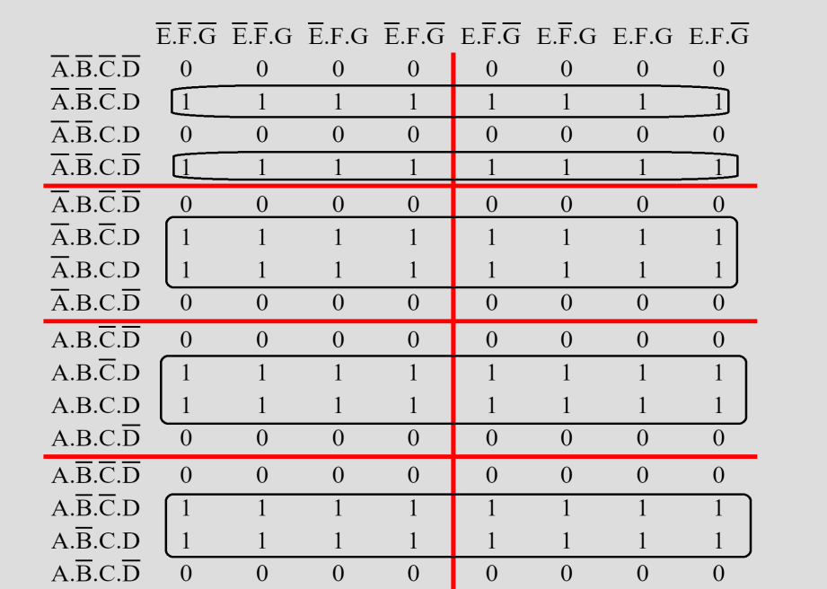

**QD=C'D + BD + AD + A'B'CD'**

**=D ⊕ (A'B'C)**

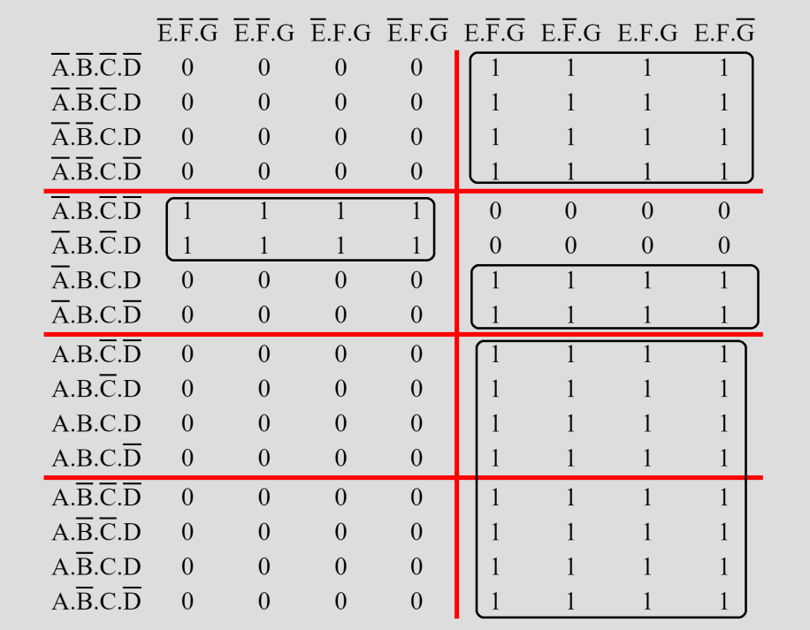

**QE=B'E + CE + AE + A'BC'E'**

**=E ⊕ (A'BC')**

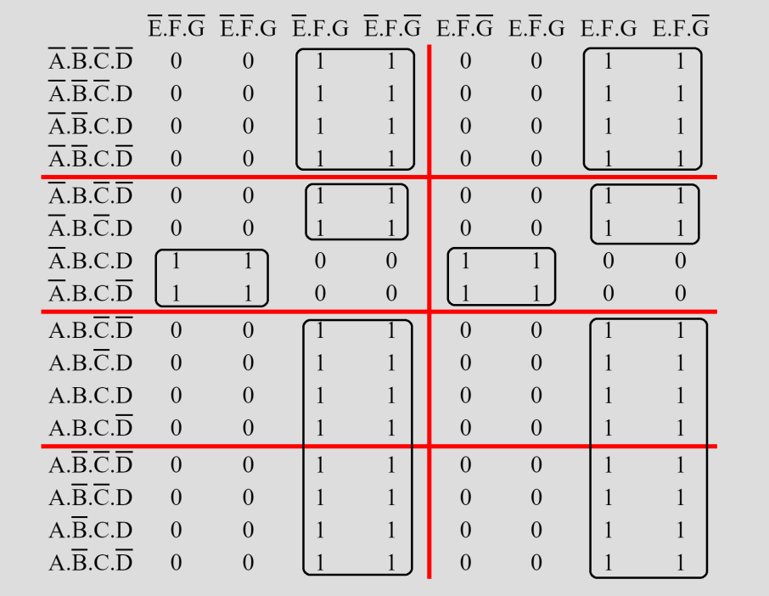

**QF=B'F + C'F + AF + A'BCF'**

**=F ⊕ (A'BC)**

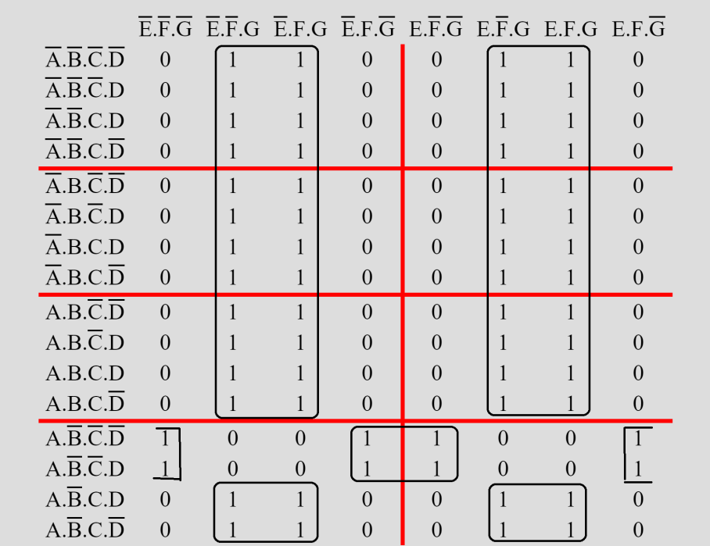

**QG=A'G + CG + BG + AB'C'G'**

**= G ⊕ (AB'C')**

The diagram below is the transition diagram for the Moore machine, showing only the useful states and transitions. The other transitions are considered in the Boolean expressions.

Here the transitions mean the number of claps in the time interval and the output in each state is the state of the appliances ( 0 meaning off and 1 meaning on ).

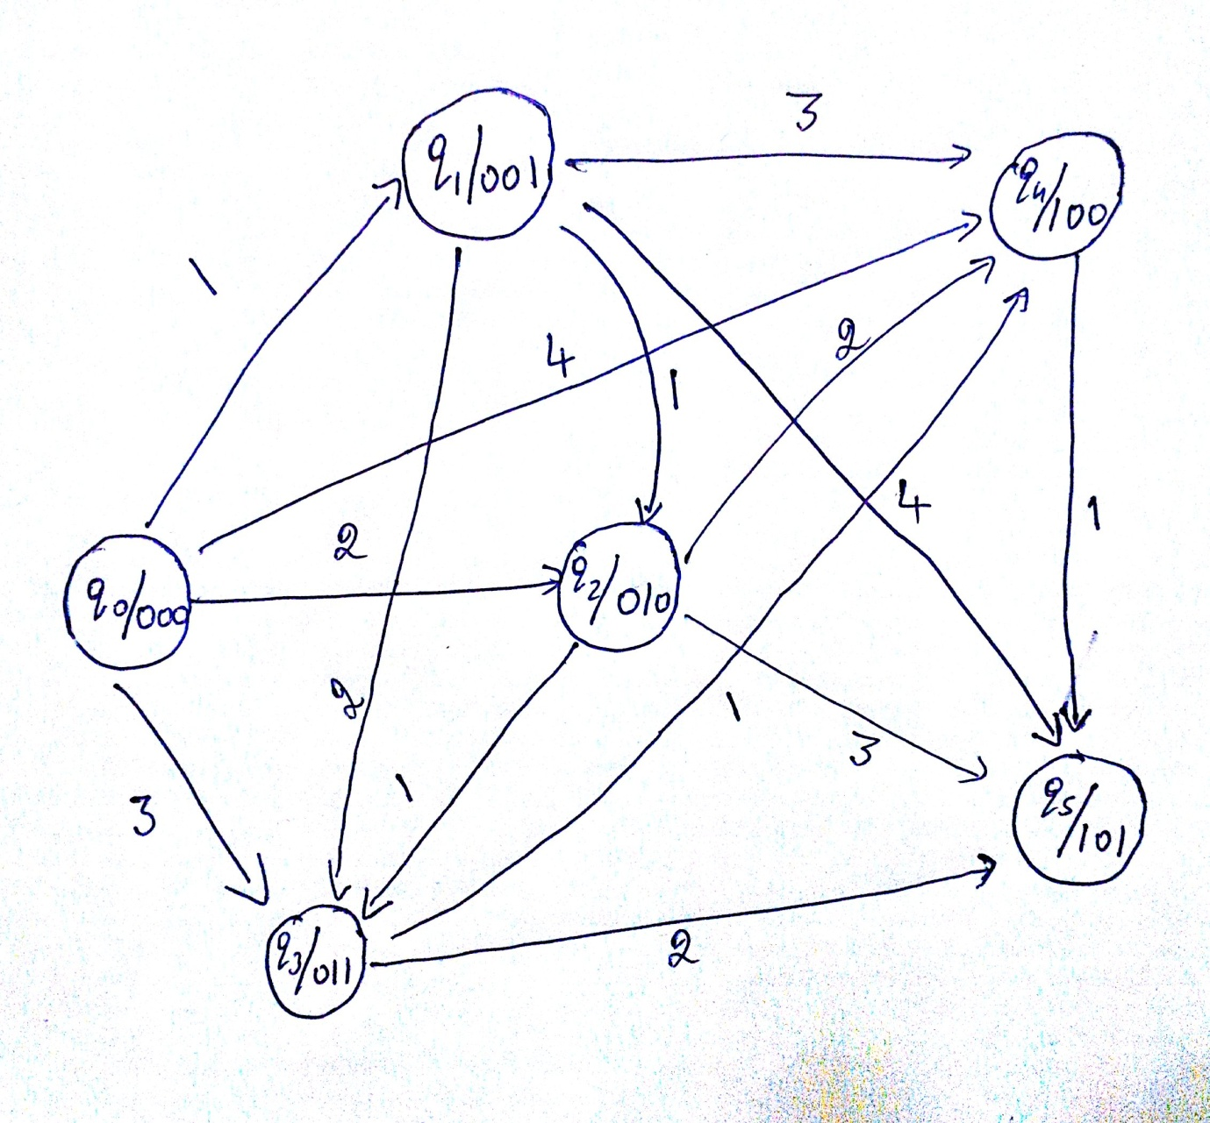

**Merits and Demerits**

**Merits**

1. Unlike conventional clap switch, which can switch ON/OFF one device, this circuit can control 4 different appliances based on the sequence of the claps. Also the circuit can be extended to more appliances.
2. The primary application involves an elderly or mobility - impaired person.
3. We can turn something on and off from any location in the room simple by clapping our hands. A clap switch is generally used for a light, television, radio, or similar electronic device that the person will want to turn on/off from bed.
4. Complete elimination of man power.
5. Energy efficient.

**Demerits**

1. Unless we use a filter in the circuit, it is not advantageous. So that the circuit activates only for the clap of particular frequency.
2. The circuit has a time span where it accepts the claps and then it resets, this depends on the clock frequencies. If a sequence of claps falls on two different time spans, then the required output is not obtained.

**List of References**

1. **https://en.wikipedia.org/wiki/Main_Page**
2. **http://www.32x8.com/**
3. **https://www.google.co.in/**